Implementing the Multi-Level Feedback Queue (MLFQ) Scheduler Using Monitors
A Technical Article on Operating-System Scheduling and High-Level Synchronization

Document Information
Field | Details
Title | Implementing the MLFQ Scheduling Algorithm Using Monitors
Authors | [Author names]
Authors | Najla Davarpanah
Course | Embedding Systems
Instructor | Majid Shamshirgaran
University / Institution | Eshragh University
Date | October 2026
Version | 1.0
Keywords | MLFQ, Scheduling, Monitor, Condition Variable, Synchronization, Operating Systems

Abstract
The Multi-Level Feedback Queue (MLFQ) scheduler keeps several ready queues that are shared by the dispatcher, timer handlers, and threads that become ready. Protecting these shared queues is the central engineering problem. Semaphores solve it, but they scatter locking logic across the program and make mistakes easy. A monitor offers a higher-level alternative: it bundles the shared data, the operations on that data, and the synchronization into one module in which only one thread is active at a time. This article presents a complete monitor-based design of MLFQ. We define the monitor's state and condition variables, give pseudocode for making a process ready, selecting the next process, updating priorities, and boosting priorities, and explain the design with a flowchart and a worked example. We also analyze correctness under Mesa-style signaling, show why the design is free of deadlock and starvation, and compare it with the semaphore-based version.

1. Introduction
An MLFQ scheduler decides which ready process runs next by observing how each process behaves. New processes start in the highest-priority queue; a process that uses its entire time quantum is demoted; a periodic boost lifts every process back to the top so that none starves. The policy is simple, but the implementation touches the same queues from several threads at once.
A monitor, introduced by Hoare and Brinch Hansen, is a programming-language construct that makes this safe by construction. All shared variables are private to the monitor, every public procedure runs with mutual exclusion automatically, and threads that must wait for a condition sleep on condition variables instead of spinning. The programmer cannot forget to release a lock, because the lock is implicit.
This article answers one question: how should MLFQ be structured when a monitor is the only synchronization tool?

2. Background

2.1 MLFQ Rules
Rule | Description
R1 | If Priority(A) > Priority(B), A runs and B does not.
R2 | If Priority(A) = Priority(B), they run in Round Robin using the quantum of that queue.
R3 | A new process enters the highest-priority queue.
R4 | A process that uses its whole quantum moves down one queue.
R5 | After a period S, all processes move to the top queue (priority boost).

2.2 Monitors and Condition Variables
A monitor has three properties:
- Encapsulation. Shared data can be touched only by the monitor's procedures.
- Implicit mutual exclusion. At most one thread executes inside the monitor at any moment.
- Condition synchronization. A thread calls wait(c) on a condition variable c to release the monitor and sleep; another thread calls signal(c) or broadcast(c) to wake one or all sleepers.
Unlike a semaphore, a condition variable has no memory: a signal with no sleeper is lost. Therefore a waiting thread must always re-check its condition in a loop.

2.3 Signaling Disciplines
Property | Hoare (signal-and-wait) | Mesa (signal-and-continue)
Who runs after signal | The woken thread runs immediately | The signaler keeps running
Condition guaranteed true on wake-up | Yes | No, must re-check
Waiting construct | if is enough | while is required
Used in practice | Rare (teaching) | Common (Java, POSIX, Linux)
This article uses the Mesa discipline because it is what real systems provide.

3. System Model and Data Structures
We assume N = 3 queues.
Queue | Priority | Time quantum | Policy
Q0 | Highest | 4 ms | Round Robin
Q1 | Medium | 8 ms | Round Robin
Q2 | Lowest | 16 ms | FCFS
Each process has a Process Control Block (PCB):
Field | Type | Meaning
pid | int | Unique process identifier
level | int | Current queue index
remaining | int | Remaining CPU burst time
state | enum | NEW, READY, RUNNING, WAITING, TERMINATED

4. Monitor-Based Design

4.1 Monitor Components
The whole scheduler lives in a single monitor named MLFQ.
Element | Kind | Purpose
Q[0..N-1] | Private data | The ready queues
ready_count | Private data | Total number of processes waiting in all queues
cpu_busy | Private data | True while a process is running on the CPU
nonEmpty | Condition variable | Dispatcher sleeps here while ready_count == 0
cpuFree | Condition variable | Threads sleep here while the CPU is busy (multi-dispatcher variant)
make_ready(P) | Entry procedure | Inserts P into its queue and wakes the dispatcher
get_next() | Entry procedure | Blocks until a process exists, then removes the highest-priority one
update_after_run(P) | Entry procedure | Demotes, requeues, or terminates P
boost() | Entry procedure | Moves every process to Q0

4.2 Design Principles
- One lock, hidden. The monitor's built-in mutex protects all queues at once. This is coarser than per-queue locking but removes lock-ordering problems entirely.
- Wait inside a loop. Under Mesa signaling every wait is guarded by while, so a spurious or stolen wake-up is harmless.
- Run outside the monitor. The process executes on the CPU outside the monitor. Only the bookkeeping is done inside, so the monitor is held for a very short time.
- Signal after state change. make_ready changes the queue first and signals second, so the woken dispatcher always finds the data consistent.

5. Algorithms

5.1 Monitor Declaration and make_ready
monitor MLFQ:
queue Q[0..N-1]
int ready_count = 0
condition nonEmpty
entry procedure make_ready(P):
enqueue(Q[P.level], P)
P.state = READY
ready_count = ready_count + 1
signal(nonEmpty)

5.2 Selecting the Next Process
entry procedure get_next():
while ready_count == 0:
wait(nonEmpty) // releases the monitor lock while asleep
for i = 0 to N-1:
if Q[i] is not empty:
P = dequeue(Q[i])
ready_count = ready_count - 1
P.state = RUNNING
return P

5.3 Updating After Execution
entry procedure update_after_run(P):
if P.remaining == 0:
P.state = TERMINATED
else if P blocked for I/O:
P.state = WAITING // keeps its level
else: // used the full quantum
P.level = min(P.level + 1, N-1)
make_ready(P)

5.4 Priority Boost
entry procedure boost(): // called by a timer thread every S ms
for i = 1 to N-1:
while Q[i] is not empty:
P = dequeue(Q[i])
P.level = 0
enqueue(Q[0], P)

5.5 The Dispatcher Thread (outside the monitor)
procedure dispatcher():
loop forever:
P = MLFQ.get_next()
run P for min(quantum[P.level], P.remaining)
MLFQ.update_after_run(P)

6. Scheduling Flowchart
The flowchart below shows one iteration of the monitor-based dispatcher.
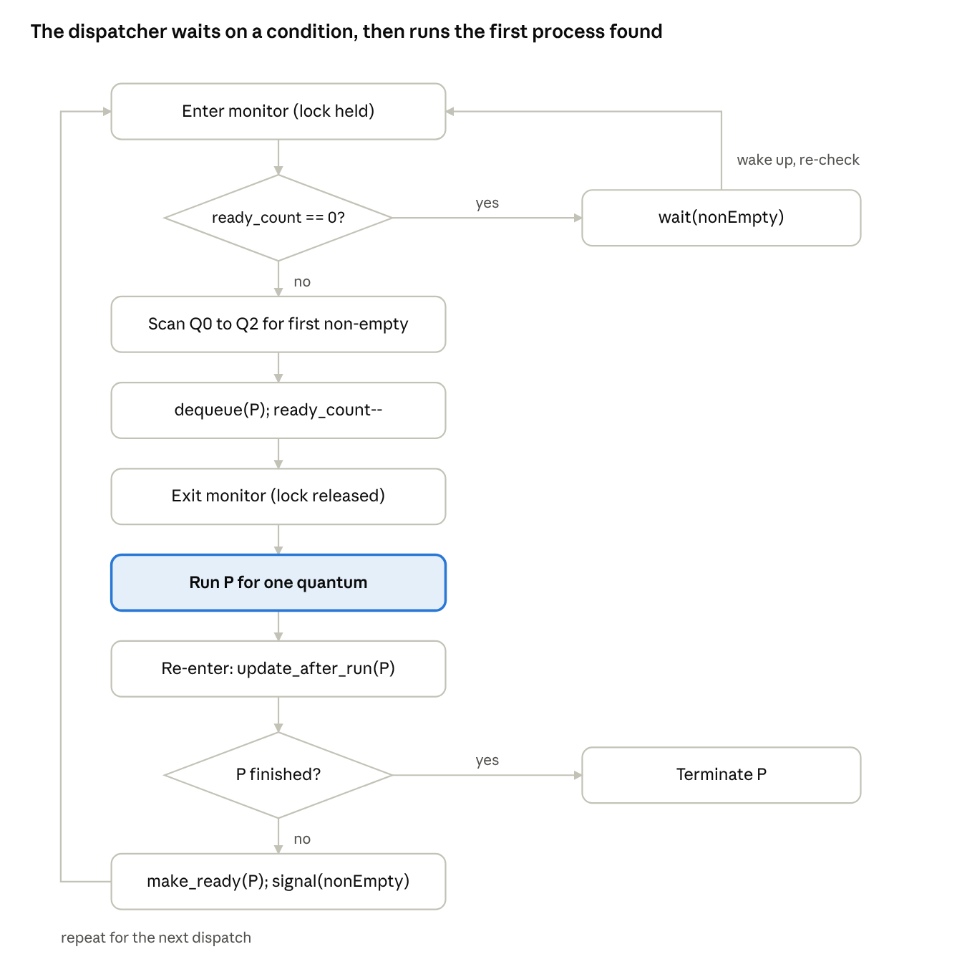
monitor-based dispatcher · 2 decisions, 2 loops
The dispatcher sleeps on nonEmpty while no process is ready, takes the highest-priority process inside the monitor, runs it outside, and requeues it unless it has finished.

7. Worked Example
Three processes arrive at time 0. Quanta are 4, 8 and 16 ms.
Process | Burst (ms) | Behavior
A | 20 | CPU-bound
B | 6 | Short, interactive
C | 12 | Medium
Execution trace:
Time interval | Running | Queue | Action
0-4 | A | Q0 | Quantum expires; A moves to Q1 (remaining 16)
4-8 | B | Q0 | Quantum expires; B moves to Q1 (remaining 2)
8-12 | C | Q0 | Quantum expires; C moves to Q1 (remaining 8)
12-20 | A | Q1 | Quantum expires; A moves to Q2 (remaining 8)
20-22 | B | Q1 | B finishes at 22
22-30 | C | Q1 | C finishes at 30
30-38 | A | Q2 | A finishes at 38
State of the monitor at selected instants:
Time | ready_count | Q0 | Q1 | Q2 | Dispatcher state
0 | 3 | A, B, C | - | - | Calls get_next()
12 | 3 | - | A, B, C | - | Running A
22 | 1 | - | C | A | Running C after B finished
38 | 0 | - | - | - | Sleeping on nonEmpty
Resulting metrics:
Process | Completion | Turnaround | Waiting
A | 38 | 38 | 18
B | 22 | 22 | 16
C | 30 | 30 | 18
Average |  | 30.0 | 17.3
At time 38 ready_count is 0, so the dispatcher sleeps on nonEmpty without consuming CPU until a new process calls make_ready.

8. Correctness Analysis
Mutual exclusion. Only one thread executes inside the monitor at any time, so every read and write of Q[i] and ready_count is atomic with respect to other monitor procedures.
No lost wake-up. ready_count is changed inside the monitor, and get_next tests it under the same lock before sleeping. A signal(nonEmpty) can therefore never occur between the test and the wait.
Mesa safety. Because wait sits inside a while loop, a dispatcher that wakes up after another thread has already taken the process re-checks ready_count and goes back to sleep if needed.
Deadlock freedom. The design has exactly one lock and the dispatcher releases it during wait. With a single lock there is no circular wait. The CPU burst runs outside the monitor, so a long-running process never blocks make_ready or boost.
Starvation freedom. The periodic boost() guarantees that every ready process reaches Q0 at least once per period S.

9. Performance Considerations
Aspect | Observation
Lock contention | One monitor lock is shared by all operations; critical sections are short (O(N)), so contention is low on small machines.
Dispatch cost | O(N) to find the first non-empty queue.
Busy waiting | None. The dispatcher sleeps on a condition variable.
Wake-up cost | signal on every make_ready costs a little even when the dispatcher is already running; it can be skipped if a flag shows the dispatcher is awake.
Scalability | A single monitor becomes a bottleneck on many cores; use one monitor per core.

10. Comparison with the Semaphore-Based Design
Criterion | Semaphores | Monitor
Abstraction level | Low-level primitives | High-level module
Mutual exclusion | Explicit wait/signal pairs | Automatic
Risk of programmer error | High (forgotten signal, wrong order) | Low
Condition waiting | Counting semaphore remembers signals | Condition variable forgets signals; needs a loop
Locking granularity | Per-queue mutexes possible | One lock for the whole scheduler
Deadlock risk | Needs a lock-ordering discipline | Single lock, no ordering needed
Language support | Any language with a library | Native in Java, C#; emulated with mutex + condvar in C

11. Conclusion
A monitor gives MLFQ a clean structure: all queues, counters, and the policy live in one module, mutual exclusion is automatic, and the dispatcher sleeps on a condition variable when no work exists. The Mesa-style while loop makes the design robust, the single lock rules out deadlock, and the periodic boost prevents starvation. The cost is coarser locking than the per-queue semaphore design. The next article combines both mechanisms to get fine-grained locking with the clarity of a monitor.

References
- Hoare, C. A. R. Monitors: An Operating System Structuring Concept, Communications of the ACM, 1974.
- Lampson, B. W., and Redell, D. D. Experience with Processes and Monitors in Mesa, Communications of the ACM, 1980.
- Arpaci-Dusseau, R. H., and Arpaci-Dusseau, A. C. Operating Systems: Three Easy Pieces, Wisconsin.
- Silberschatz, A., Galvin, P. B., and Gagne, G. Operating System Concepts, Wiley.

